**Physics: Speed and Acceleration**

**Mini test**

**Name:**

1. What’s the difference between speed and acceleration? (2 marks)

|  |
| --- |
|  |
|  |
|  |

1. How is distance different from displacement? (2 marks)

|  |
| --- |
|  |
|  |
|  |

1. Use the below formulae to complete the questions. Show your working.

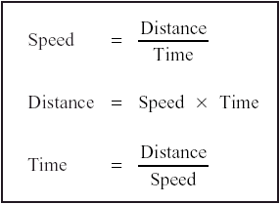

*Multiply by 3.6 to convert m/s to km/hr*

*Divide by 3.6 to convert km/hr to m/s*

1. An airplane flies from Perth to Sydney at an average speed of 820km/h and arrives in five hours. How far has the plane travelled? (2 marks)

|  |
| --- |
|  |
|  |
|  |

1. Tim hikes 10km in two hours. What’s his average speed in metres per second? (2 marks)

|  |
| --- |
|  |
|  |
|  |

1. A cyclist rides 5km to work every day at a speed of 4m/s. How long is his commute? (2 marks)

|  |
| --- |
|  |
|  |
|  |

1. There once was a speedy hare who bragged about how fast he could run. Tired of hearing him boast, a tortoise challenged him to a race. Below is the graph of that race.

Answer the questions below and show your working. 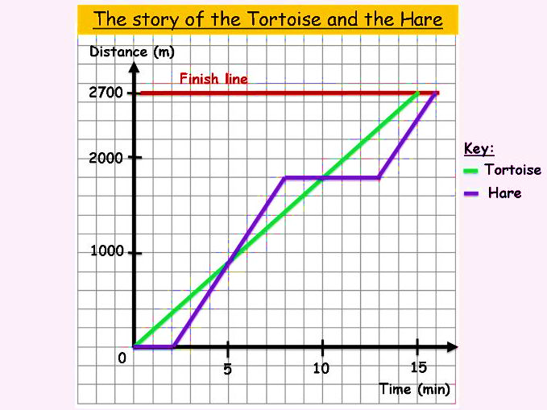

1. Calculate the tortoise’s speed across the whole race. (2 marks)

|  |
| --- |
|  |
|  |
|  |

1. How fast is the hare travelling in the last three minutes of the race? (2 marks)

|  |
| --- |
|  |
|  |
|  |

1. Describe the hare’s motion at the ten-minute mark (1 mark)

|  |
| --- |
|  |
|  |
|  |

1. Which animal won the race? (1 mark)

|  |
| --- |
|  |

1. Use the below formulae to complete the questions. Show your working.

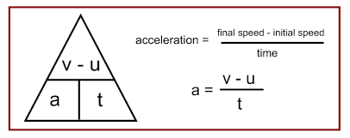

*final speed =*

*initial speed + (acceleration x time)*

or

*v = u + at*

1. A car speeds up to 60km/hr from sitting at a red traffic light, in 8 seconds. Calculate his final acceleration. (2 marks)

|  |
| --- |
|  |
|  |
|  |

1. Bob is running at a speed of 6 m/s, and accelerates at the rate of 2m/s for 4 seconds. What’s his final speed? (2 marks)

|  |
| --- |
|  |
|  |
|  |

Mark: /20 %

Current total for mini tests: /60 %